Template for Evidence(s)
SAMPLE
UI GreenMetric Questionnaire

University : ...
Country : ...
Web Address : …

[1] Setting and Infrastructure (SI)

[1.15] Campus facliities for disable, special needs and or maternity care (SI.5)

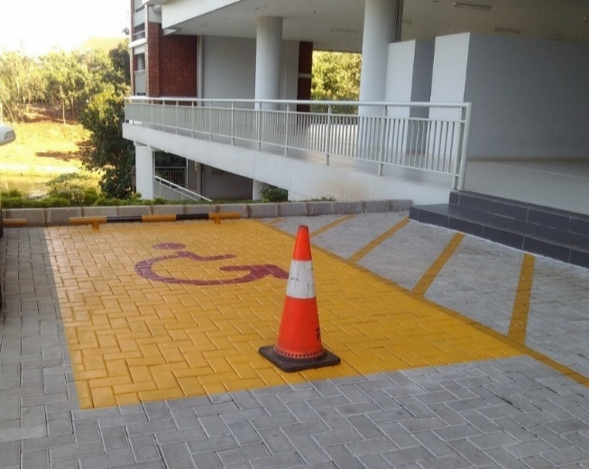 |  | 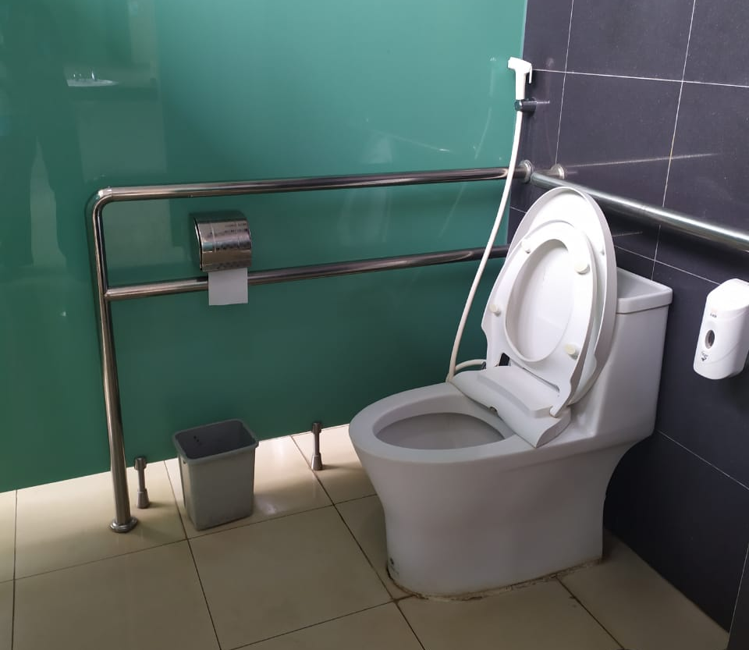
- Disabled parking (Universitas Indonesia, Indonesia) | - Accessible toilet (Universitas Indonesia, Indonesia)
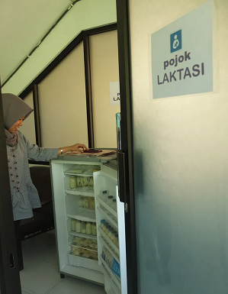
- Lactation Room (Universitas Airlangga, Indonesia)

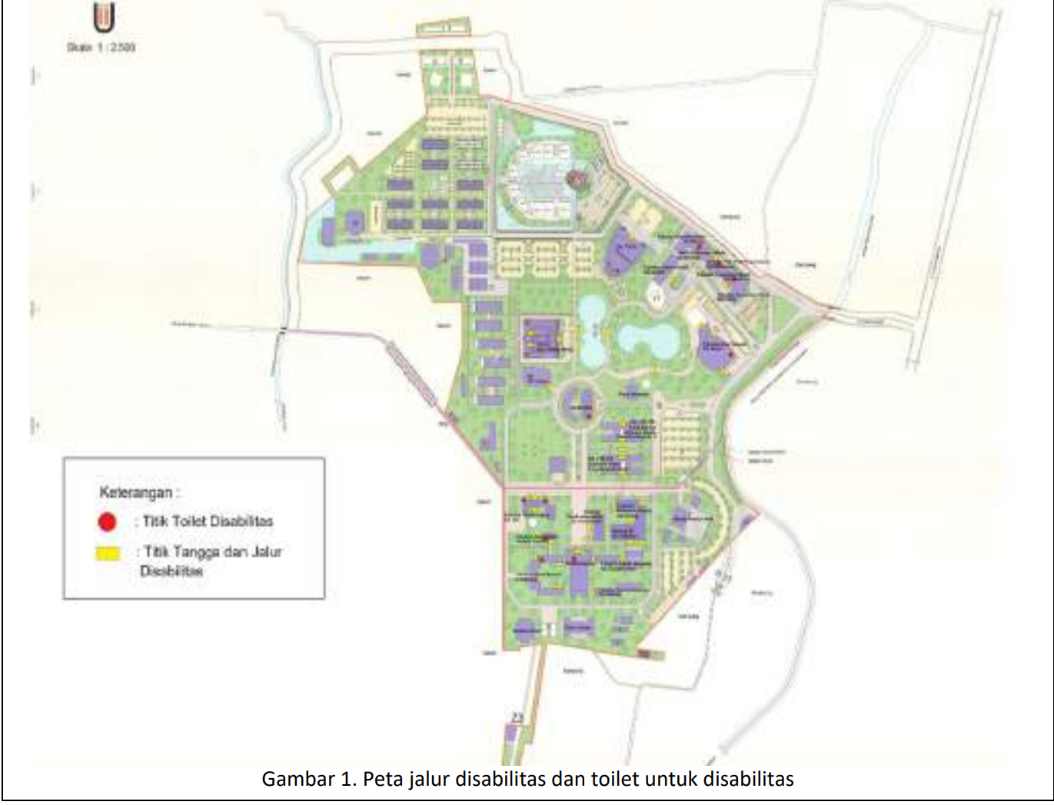
Description:
(Please describe the Campus facliities for disable, special needs and/or maternity care in your campus. The following is an example of the description. You can describe more related items if needed.)

For each facility, provide a campus map showing the locations of these facilities and clearly identify the buildings with these services. You can also list each building, specifying the type of facility available in each, such as in a table format (e.g., Building 1 - lactation room, accessible toilet). The evidence provided should be clear, showing exact locations on the map. The evidence provided may also include maps showing the location, area size, or distribution of facilities relevant to the indicators

- Disabled parking for disabled people to park their car which located at the nearest space bulding
- Accessible toilet for disabled people
- Lactation room is private room for staff who are breasfeeding can pump breast milk in private

Additional evidence link (i.e., for videos, more images, or other files that are not included in this file):
- https://fkm.unair.ac.id/pojok-laktasi-fkm-unair-fasilitas-yang-memadai-hingga-research-group/

